Meet My Team
Fresno Mental Health Training Program Bio’s
Doctoral Internship in Clinical Psychology

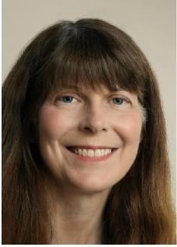
Diane Kawagoe, PhD
Fresno Doctoral Internship Training Director
I’m the Training Director at Fresno. I started my career with KP in 1996 as a staff psychologist in the Intensive Outpatient Program-Adolescents and Behavioral Medicine Services. I completed my Ph.D. at the University of Kansas, internship at the Colmery-O’Neill Veteran’s Administration Medical Center in Topeka, Kansas, and post-doctoral hours at an in-patient facility at St. Mary’s Hospital in Manhattan, Kansas. I moved to the Fresno area to join a private practice and teach part time at California State University, Fresno before joining the Kaiser Permanente team. This move aligned well with my professional training and practice working in a multi-disciplinary setting. In 2000, I became the Training Director and have focused on the creation and evolution of a dynamic, well-integrated psychology internship program. I was the lucky recipient of a well-organized and rich internship and it is my hope that the KP training program is a way to “pay it forward” as a form of gratitude.
Our training program brings a special energy into the mental health department and we work together to provide a rich, generalist training atmosphere. We are also fortunate to have the full support of the management team and the Regional training program. Our supervision team is comprised of dedicated and enthusiastic psychologists who contribute energy to the program and each other. I particularly enjoy the team’s open and collaborative approach to training as well as the new ideas and zeal interns bring into the program each year.
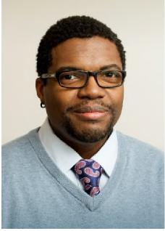
Treon Hinmon, PsyD
Behavioral Health Manager I for the Adult Team
Fresno Doctoral Internship Co-Training Director
I have worked in mental health in the Central Valley for over 20 years. Starting as a counselor for troubled teens, I have understood the need for decisive intervention, compassionate care, and a down-to-earth approach that makes the patient feel both comfortable and understood. Those early experiences motivated me to earn my Doctorate in Clinical Psychology right here in Fresno over 15 years ago. Throughout my career I have valued the opportunity to provide quality, effective treatment to adults, kids, teens, couples, and families in a variety of settings. I am delighted to join the excellent, knowledgeable, professional staff here at Kaiser Permanente Fresno.
Roles and Responsibilities
My approach to treatment is straightforward. I believe that people are doing the best they can with the knowledge and resources they have available. Sometimes people struggle with the challenges of life. When struggles arise, I believe we have the opportunities to learn, grow, adapt, and make healthy changes. Psychotherapy is a resource that can provide knowledge, support, and guidance during those times to maximize one’s opportunities for health, stability, and engagement in the activities of daily living. I believe in empowering people to make positive decisions and take constructive action for a healthy mind, body, and spirit. My expertise is in Cognitive Behavioral Therapy, focusing on the analysis of patterns of thought, emotion, and behavior. I believe that with awareness, insight, problem-solving, commitment, and discipline, it is possible to not just live... but Thrive!

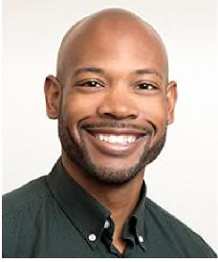
Frederick Hives II, PsyD
Adult Team
I obtained my bachelor’s degree in communication studies with a minor in psychology from Cal Poly – San Luis Obispo before earning my doctorate degree at John F. Kennedy University in Pleasant Hill, CA. I completed my predoctoral internship at California Department of State Hospitals – Vacaville, then completed a two-year postdoctoral fellowship in neuropsychology at Patton State Hospital. I joined Kaiser Fresno in 2017 and have served as an assessment supervisor for psychology interns since then. In 2021 I earned board certification in clinical neuropsychology through the American Board of Professional Psychology.
As an assessment supervisor, I enjoy helping interns expand their knowledge of various psychological and neuropsychological tests and their understanding of how testing results can inform ongoing treatment. Interns’ testing experiences may range from minimal to extensive, and I try to build upon the skills they possess. Each year, I hope to learn from interns and to help them develop greater confidence in understanding testing data as well as their skills as evaluators as they grow into professionals. In my time away from the office, I enjoy reading, exercising, visiting local restaurants, and traveling.

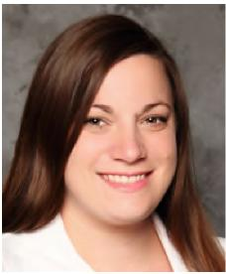
Jennifer Mehling, PsyD
Adult Team
My name is Jennifer Mehling, and I am a Clinical Psychologist. I obtained my bachelor’s degree in Psychology from Cal Poly – San Luis Obispo and my master’s and doctorate degrees from Alliant International University – Fresno. I completed my predoctoral internship at Kaiser Permanente, Fresno in 2011-2012. I returned to Kaiser in the Central Valley Service Area in 2013 to develop the Adult and Family Medicine Behavioral Medicine program where I eventually became a manager of the department and helped develop additional programs in Adult and Family Medicine, Chronic Pain, Oncology, and Women’s Health. I transferred to our Fresno Clinic in March of 2018. Currently I work in the Adult Psychiatry Department. As a clinical supervisor, I enjoy supervising interns in both the Behavioral Medicine and Psychiatry Departments. My areas of interest are Health Psychology, Cognitive Behavioral Therapy, and Existentialism. I provide several didactic seminars on these topics throughout the year. I have also co-supervised the intern research project. In my time off, you’ll usually find me reading, writing, or spending time with my husband and kids.

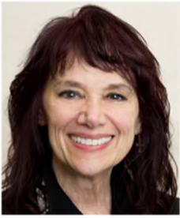
Maria Rubino-Gaab, PhD
Adult Team
The integrated care model is one of the primary reasons I chose to practice neuropsychology at Kaiser Permanente Fresno.
Neuropsychology focuses on how behavior and skills are related to brain function. A neuropsychological evaluation consists of a thorough interview of the patient that includes relevant information such as medical history, medications taken, and functional abilities. The collegial model of Kaiser Permanente enables efficient consultation with therapists, physicians, and specialists providing important communication regarding individual patient care. Neuropsychological testing evaluates the function of the brain using objective instruments (paper and pencil tests and some computerized tests) that measure learning, memory and thinking skills. The results of these tests provide patterns of strengths and weaknesses that can assist in diagnosis and treatment planning and assist healthcare providers to give informed recommendations to patients. Besides communicating with patients' healthcare providers, these results are also discussed in detail with the patient using "every day" language, so patients can better understand their own symptoms or complaints involving memory or thinking.
Roles and Responsibilities
My professional areas of interest and expertise include neuropsychology, cognitive rehabilitation, and psychotherapy for adults who have mentally or physically disabling conditions including intellectual/developmental disabilities, acquired and/or traumatic brain injuries, neurodegenerative disorders, spinal cord injuries, and individuals who have multiple physical and mental impairments. Assisting in the education of psychology interns in the testing and diagnostic process is integral to providing solid treatment planning for our members.
Professional Affiliations
- International Neuropsychological Society (Member)
- American Psychological Association (Member)
- California Psychological Association (Member)

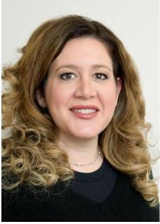
Rachel Richardson, PsyD
Adult Team
Hello,
My very first practicum experience was in Behavioral Medicine at Kaiser in 2003. I had a Health Psychology emphasis in graduate school and ended up in the California Department of Corrections and Rehabilitation for my postdoc working on program development for pregnant and postpartum female offenders. I started supervising Interns and Postdocs right after becoming licensed in 2009 and it is still one of my favorite clinical responsibilities. My interest and experiences branched out from there as I developed a passion for working with the severely mentally ill population in a prison environment which I did for about 5 years. I love a challenge and when I was transferred to a “level 4” (highest custody level) yard to work with ex-gangsters and youngsters who could not seem to play well with others in the prison population I was a little nervous but found the 2 years with that population to be some of the most clinically satisfying work I have done. Many of the inmate patients on my caseload received life sentences as minors or in very early adulthood and were now middle aged facing the possibility they will be living as free men for the first time (due to law changes). In 2015 I accepted a position on the Executive Team for Valley State Prison where I worked alongside the Chiefs of Medical, Dental, and Nursing to improve care and efficiency throughout the prison. While I enjoyed that position, I missed clinical work and when Kaiser Recruiters came knocking, I answered the door. I had always told myself I would return to Kaiser at some point as I have been a Kaiser patient for the majority of my adult life and strongly support their focus on prevention and the promotion of healthy living as well as the integration of services/providers.

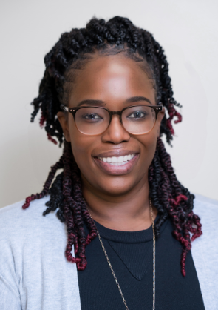

Melabi Amponsah, PhD
Adult Team
Hello! My name is Melabi Amponsah and I am a clinical psychologist. I received my bachelor’s degree in Psychology from Pacific Union College and my master’s degree and PHD from Rosemead school of Psychology, Biola University. I moved to Fresno, CA in August 2018 for my predoctoral internship at Kaiser Permanente Medical Center, Fresno. I completed the Adult team rotation, Adolescent IOP, and minor rotations in AMRS and BMS. After completing my predoctoral internship, I was hired to work full-time as a Psychological Assistant for Kaiser Permanente, Fresno as I collected my hours for licensure. In 2022, I transitioned to my role as a Clinical Psychologist in the Adult Psychiatry Department. I conduct individual therapy, group therapy, psychodiagnostic assessments, and short- term disability evaluations. I also joined the internship training program in 2022. I am excited to add a unique perspective to the training team because I started as an intern in this program and have now transitioned to a psychologist and supervisor at this facility. Still working in this department speaks to how highly I value the training I received and the work that I do here!
My clinical experiences include providing care for those dealing with depression, anxiety, life transitions, relational problems, women’s issues, racial/ethnic issues, and young- adult related concerns. When I am not at work, I enjoy spending time with my family and friends, going on road trips, completing puzzles, and going to the gym.

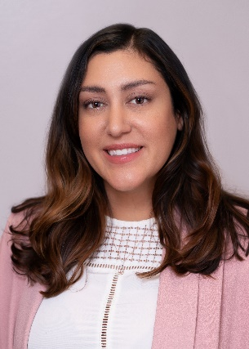

Mayari Hodgdon, PhD
Adult Team
Hello, my name is Mayari Hodgdon. I am a licensed clinical psychologist. I am currently a delegated supervisor for interns working within the Adult Intensive Outpatient Program. I obtained my doctoral degree in Clinical Psychology at the California School of Psychology, Alliant International University Fresno. My work at Kaiser has afforded me a variety of clinical experiences. Currently, I work within the Intensive Outpatient Program (IOP) for both Adults and Adolescents. Within the Adult Psychiatric team, I provide psychological assessments and facilitate the online Acceptance and Commitment Therapy group. The IOP rotation facilitates opportunities to enhance clinical skills across all diagnoses with a very diverse group of patients. It is my goal that interns within the IOP rotation will become proficient in working effectively within an interdisciplinary team, leading psychoeducation groups, process led groups, and completing through risk assessments. I approach supervision as a collaborative process, in which I can help interns meet their training goals and develop confidence in becoming independent mental health clinicians. When I am not working, I enjoy spending time with my family and engaging in a variety of hobbies including running, crocheting, hiking, and crafts.

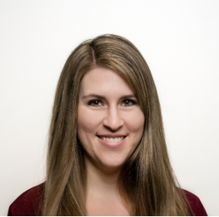

Jenny Nichols, PsyD
Child Team
My name is Jenny Nichols and I am a Licensed Clinical Psychologist. I obtained my bachelor’s degree from Santa Clara University, my masters from San Diego State University and my doctorate from the University of La Verne. I completed my internship through the University of Texas, Health Science Center in San Antonio, TX. I began my career at Kaiser Permanente and completed my post-doctoral residency at Kaiser in Antioch in 2014. I worked at Kaiser in Antioch form 2014 to 2018. In 2018, I married my husband, moved to Roseville and began working at Kaiser in Roseville. After having two children, my husband and I moved to Clovis to be closer to family and I started working at Kaiser in Fresno on the Child Team in October 2022. I provide psychological services to children, adolescents, and their families, including psychotherapy, ASD screens, and ADHD assessments. I also provide psychotherapy services for adolescents with disordered eating and co-facilitate the Teen DBT for Disordered Eating Group.

